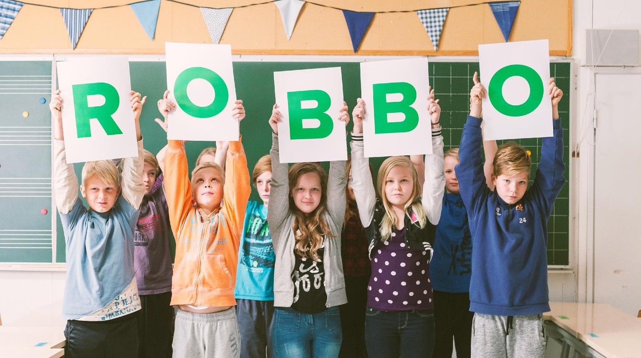

COMPANY PRESENTATION

2023

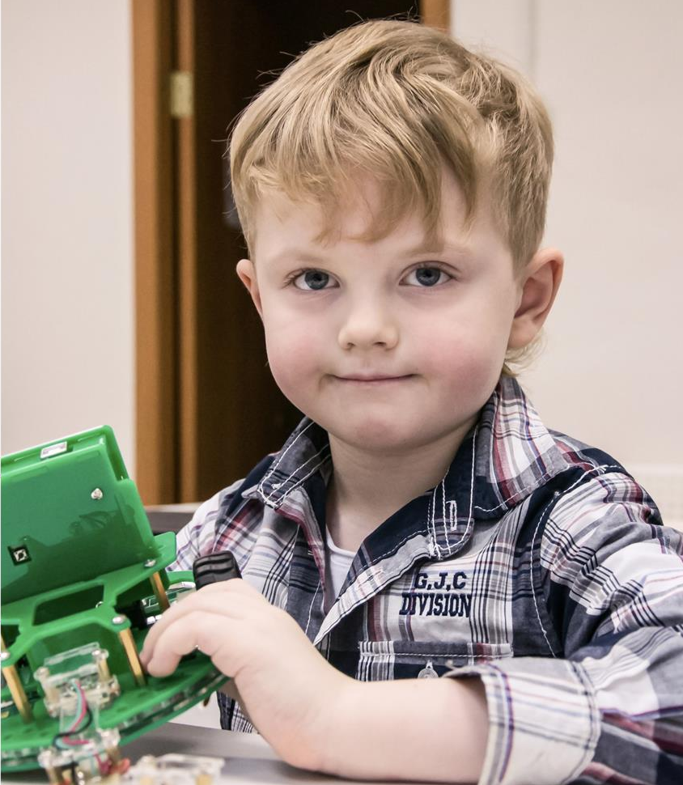



PROBLEM
OF THE WORLD EDUCATION

Modern technology education taught as magic and shapes thinking in the spirit of the “black box”.


Under renowned educational concept STEM “T” for technology and “E” for engineering are paid not enough attention.
PROBLEM

STEM is a curriculum based on the idea of educating students in four specifics disciplines — Science, Technology, Engineering and Mathematics.






SCIENCE
TECHNOLOGY
ENGINEERING
MATHEMATICS

STEM distribution by age groups:
74%
pre 5 and
5 years old:

48% 55% 13% 25% 13% 25%
56%

SOURCES: The Joan Ganz Cooney Center, 2017.

ROBBO SOLUTION:
STEM + Art + Robotics = STREAM

SCIENCE
Physics Study of the effect of friction on the speed
of the robot Biology
Environmental Monitoring.

TECHNOLOGY
Choose the optimal material and develop the body of the robot.

ART
ROBBO Story (tale),
robe theater, 3D souvenirs.

 ENGINEERING
Virtual smart home, the layout
of a real smart home.

MATH
Variables, negative numbers,
coordinate system, PID controllers.

ROBOTICS
Work with real robots,
DIY robot.

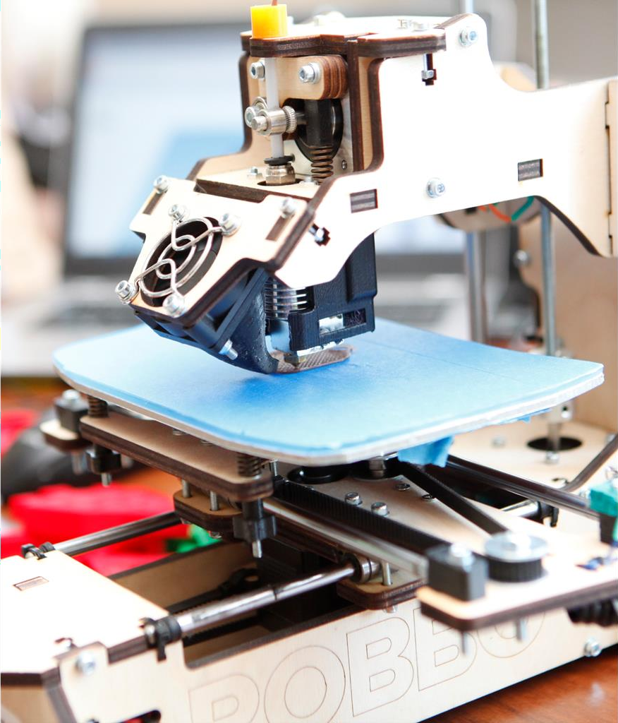



TECHNOLOGICAL INNOVATION

ROBBO has created a set of equipment and electronic educational complex, which allows children to be truly creators, educators use modern technology
and everything together develop your technology and engineering free software skills and hardware.

ROBBO created robot that enables kids
SOLUTION
to be truly creators and develop their Technology
and Engineering skills.

Key characteristic:
Easy-to-use Support teacher and motivate students. ROBBO™ unique robotic platforms are educational tools for children to learn the basics of technology, engineering and coding.

Designed for mass adoption Schools and clubs. Do not require prior knowledge
from both teacher and students.

Ready to use and complete advance tasks
No need to assemble basic models, kids just learn
by changing parts of robots and programming the motion.

Designed and manufactured in Finland
Platform, robots and educational materials were developed
in cooperation with Helsinki University, Department of Teacher Education and Finnish secondary schools from Innokas-network, CE certified.

ROBBO has 3 products already that altogether
TECHNOLOGY
meet demand on “T” and “E” in STEM concept.

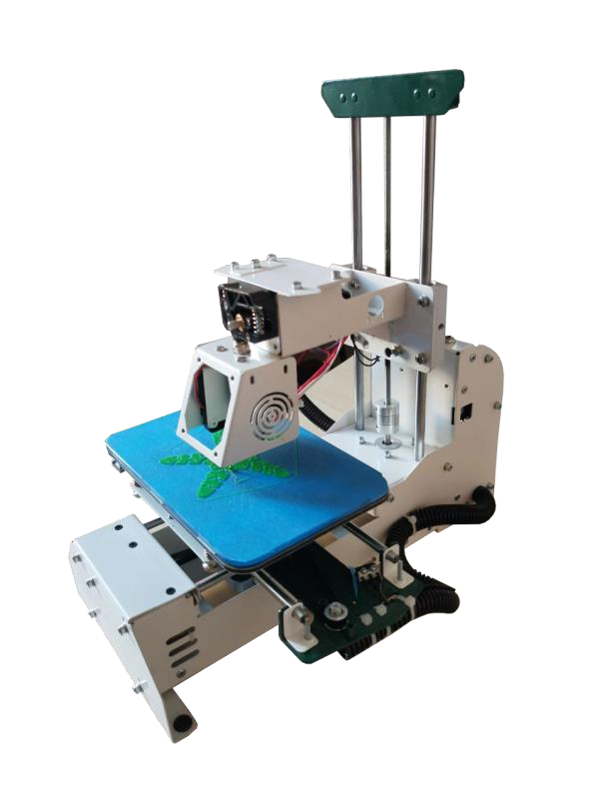
Existing products:

ROBBO 3D PRINTER
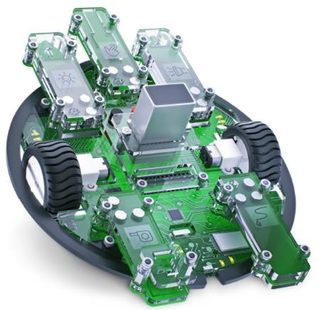
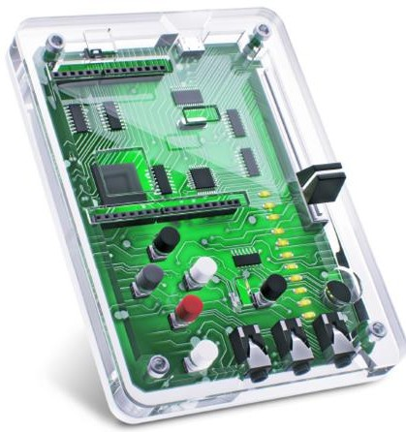

ROBBO KIT ROBBO LAB

Comprehensive robot construction kit with
5 simple magnetic-mount sensors and led light.

Kids may replicate complicated technologies by programming robot and changing.
and combining sensors

For kids of 5-15 years old
Very easy robot to enter the world of technology.

This robot is not able to move on its own but brings closer understanding of light, sound, etc.

For kids of 5-15 years old.
Proprietary developed 3D printer.

Kids may create parts of robots to construct and program it further according to study plan.

For kids of 9-15 years old.

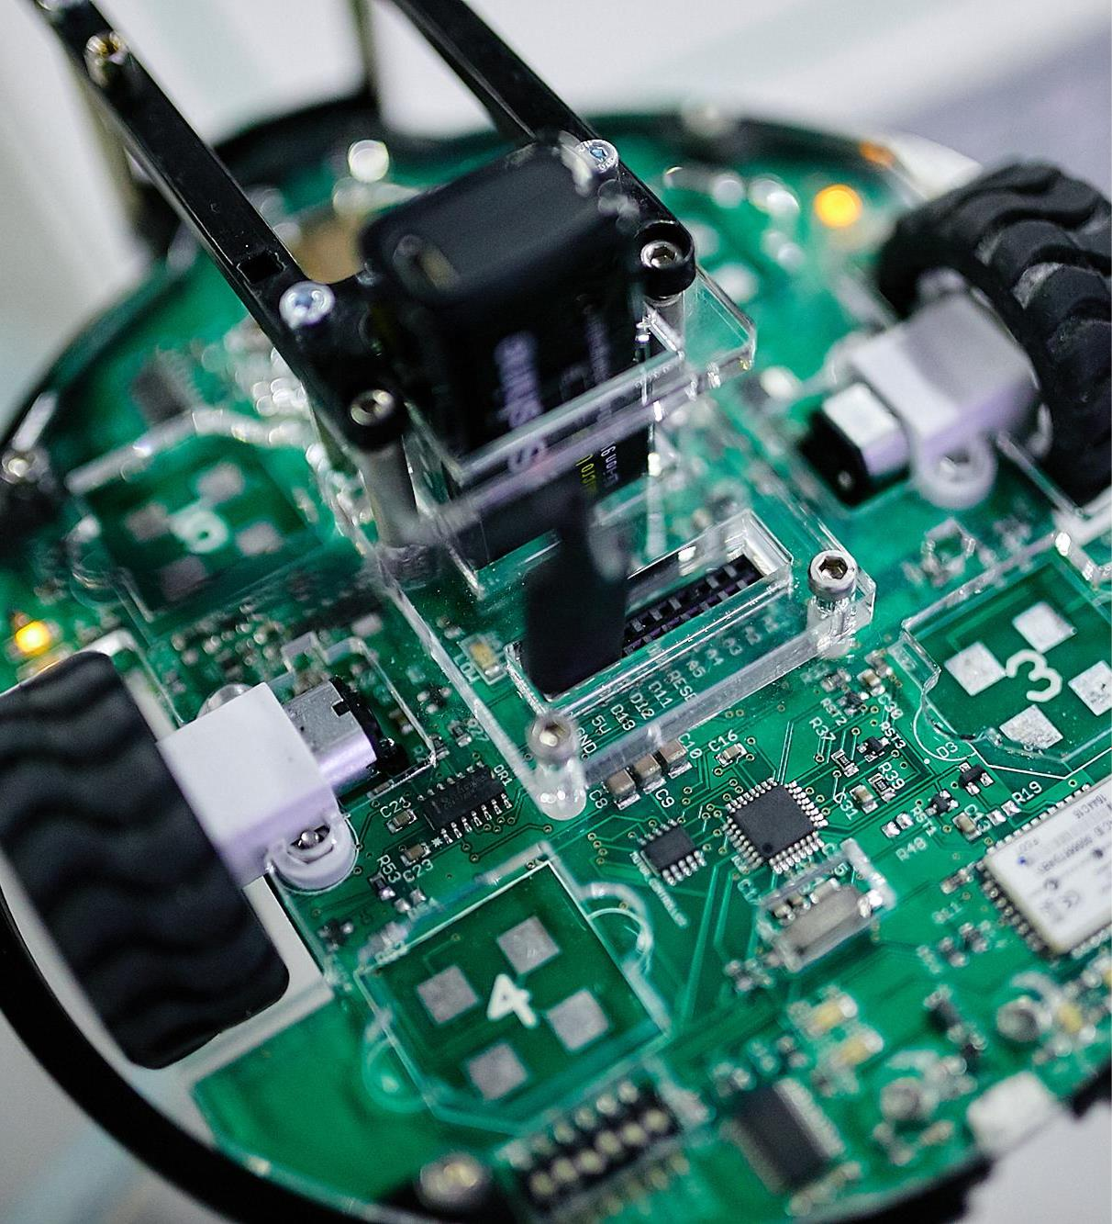

PRODUCTS
For the modernization of school and out-of-school education, ROBBO has a complete solution.

ROBBO CLASS
FOR EDUCATION
FOR SCHOOLS
HARD
SOFT
CURRICULUM
+ TEACHER TRAINING

B2B PRODUCT.

ROBBO CLASS
ROBBO Club
In Thailand, Bangkok

ROBBO represents two products on the EdTech global market:

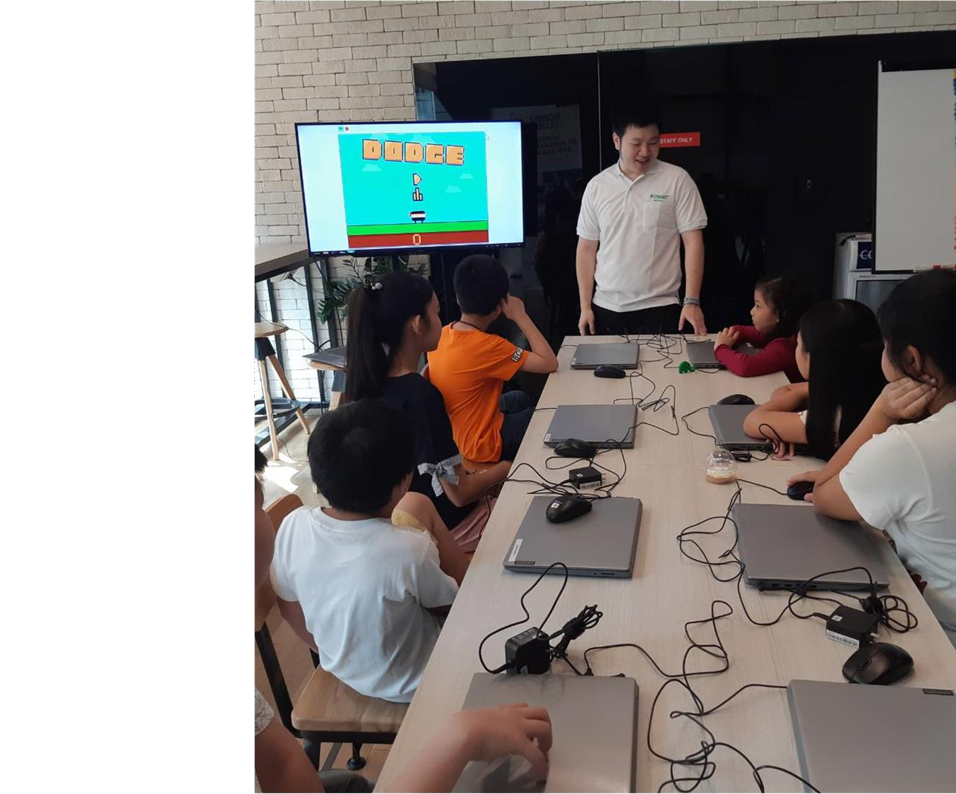ROBBO Class is a solution for educational institutions that includes a set of equipment, software and teaching materials for training young innovative engineers of the future
in the field of creative programming, circuit design and microelectronics, mobile Robotics, Internet of Things (IoT) and smart home,
3D prototyping and 3D printing.

ROBBO company is a free educational
robotics on open software and hardware.

ROBBO products are represented in 27+ countries of the world.

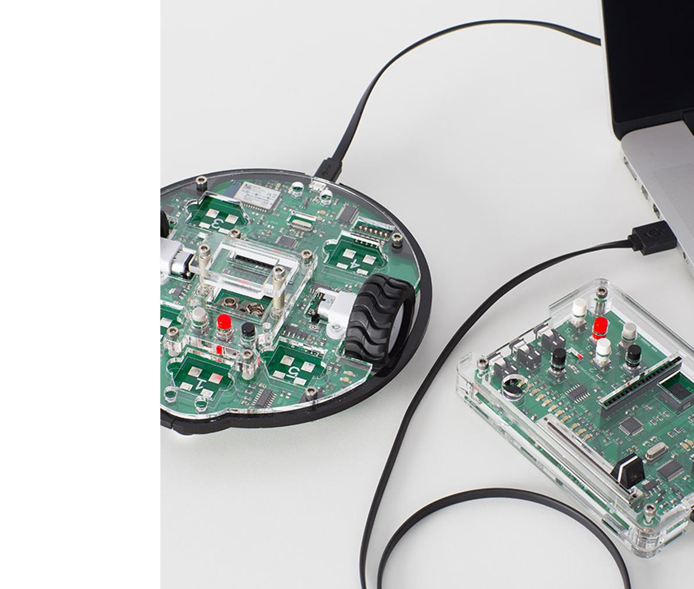

CLASS
We develop an educational class to foster STEM education.

ROBBO CLASS offer:

COMPLETE SOLUTION TO HAVE ROBOTICS CLASS IN YOUR EDUCATION CENTER:
Equipment and technical support.
Subscription to curriculum for 5-15 years old kids. Online teachers training.
Technical, methodological, soft support team.

Fast growing market of educational robots will almost double in 2 years.
MARKET

World robotics market: CAGR
2018-2020:

Revenue, $bn
2,29 2,70 3,25 3,96 4,87 6,05

23%
2015 2016 2017 2018 2019 2020

Shipments, ths units

Key trends:

Market of robots is expected to grow at 23% annually.
Educational robots are a substantial segment of the whole market: volume share is around 30%.
Segment of educational robots is dynamic and will grow at 50%

Household robots Toy and educational robots

40 000
30 000

20 000
50%
per annum.

10 000

0
36%

2015 2016 2017 2018 2019 2020

SOURCES: Tractica, Aranca.

TEAM We have experienced professionals in our team.





Maria Hakkarainen
CEO, ROBBO Finland
Maria Hakkarainen, more than 14 years of experience on international market as an entrepreneur.
More than 5 years of experience in IT educational business, educational club's management.
Catherine Ekalo
B2B products director
More than 35 successful franchises.
More than 6 years of project management for the development and promotion of franchises.
Pekka Viljakainen
Project advisor
Founder of company: Oy Visual Systems Ltd.
Business consultant of many multinational corporations and business schools.
Investor, business angel and
adviser of high-tech companies.
Pavel Frolov CMO
Founder of IT-companies: GNU/LINUXCENTER,
SunRadio, publisher Linux Format

More than 17 years of project management in the IT sector.


20
Hardware and software development
15

Sales & marketing
20

Technical and curriculum support
10
Finance
and administration

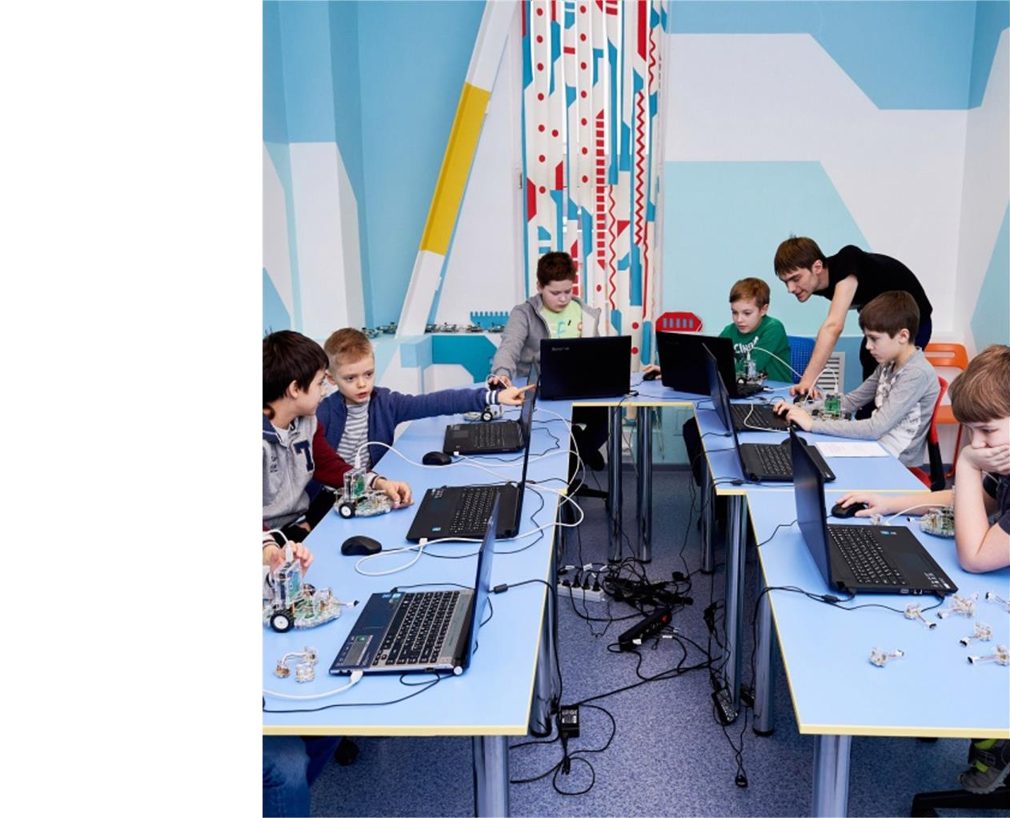ROBBO MISSION

To prepare people for a promising highly paid creative profession
in the world of the future, where all the monotonous work is done by robots:

1 Seller of robots and technological entrepreneur.
2 Operator of robots.

3 Robot programmer.

4 Service engineer of robots.

5 Innovative engineer developing future robots.

6 IT developer.

KEY ACHIEVEMENTS AND RESULTS OF ROBBO
Our performance was graded by Google and Finnish government.
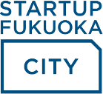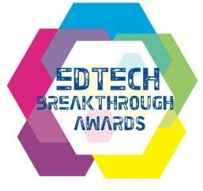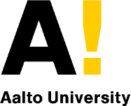

Winner of 2013 and 2014 Google RISE Awards — an annual grants program for organizations worldwide that promote computer science education opportunities.

Winner of 2014 FINLANDING – a business contest for Russian hi-tech companies interested
in establishing in Finland, organized and supported by Finnish government.

Winner of STARTUP FUKUOKA City Award – a business contest to promote the city’s startup community, organized by local Fukuoka government.

ROBBO CLUB - winner of the Next-Gen School Solution by EdTech Breakthrough Awards in 2021

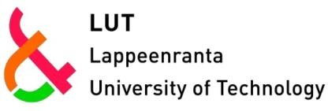

Partner of Lappeenranta university of technology and Aalto University (Finland).

RESULTS OF ROBBO:

100.000+ children are enrolled in schools and circles of 27+ countries of the world: Finland, Thailand, United Kingdom, USA, Spain, Vietnam, China, Kazakhstan, Belarus, Ukraine, Georgia, Turkmenistan, Israel, Germany, Italy, Japan, Latvia, Romania, Nigeria,
RSA, Turkmenistan, Bangladesh, Slovakia, Norway, Austria, Bulgaria.
Sold 150+ franchises ROBBO Club.

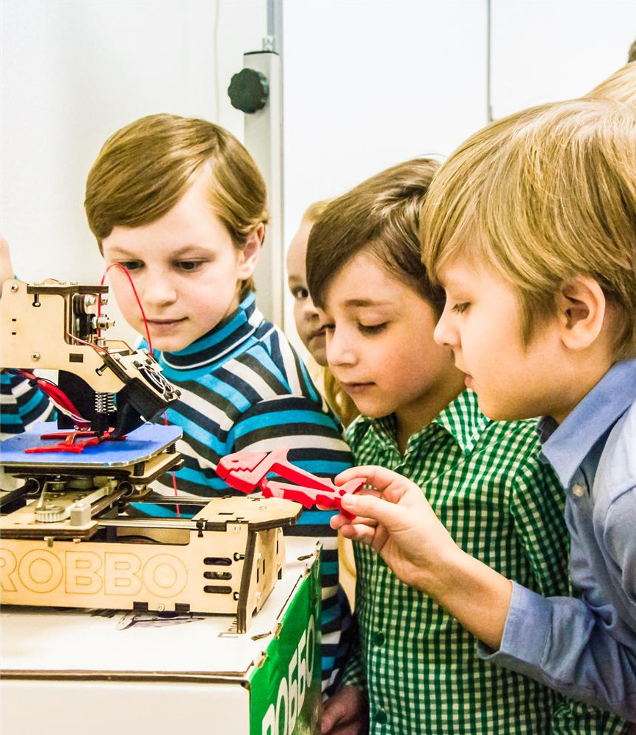

ROBBO KEY MESSAGE

If you want your child to have a high-paying profession in the world of the future, were
all the work is done by robots - send the child to study at the nearest ROBBO Club.

If there is no ROBBO Club near your house –
open it according to our franchise.

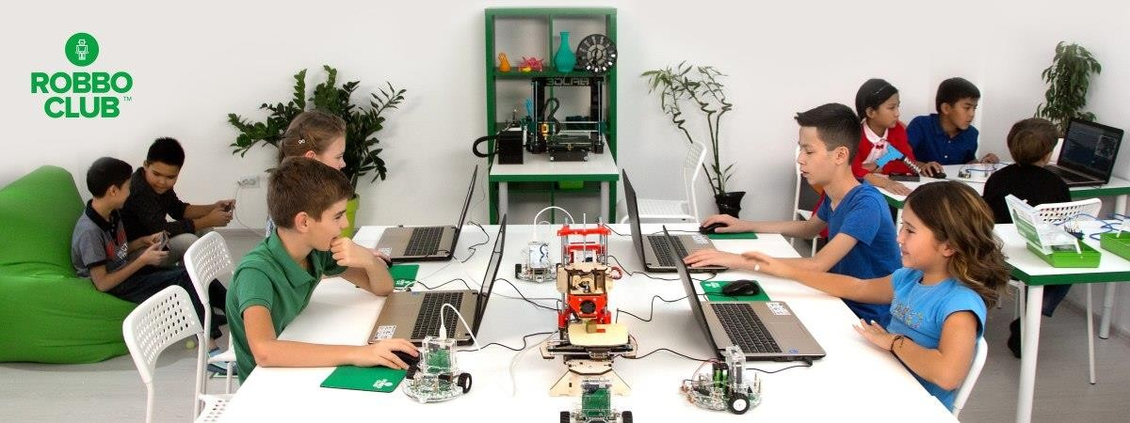
ROBBO CONTACTS

Call us: +966554411517
E-mail us: robbo@wisdomnations.org

