




OBBO

- s
•
•


Basic Robotics 7­10­2.
30 lessons of 90 min
Basic Robotics 11­15.
30 lessons of 90 min

Project activities 30 lessons of
90 min
*in developing

Project activities 30 lessons of
90 min
*in developing

Basic robotics 30 lessons of
90 min
*in developing
Basic Robotics 7­10.
30 lessons of 90 min

Game Robotics 5­6.
60 lessons of
40 min


Game Robotics 6­7.
60 lessons of
45 min
rd

Basic robotics 11­15. | Basic robotics
30 lessons of 90 min | 30 lessons of
 | 90 min
 | *in developing





We hold competitions and
school oympiads in programming and robotics, in which your students will be able
to take part
We conduct additional training
of teachers to be confident in their professional level.

Every 6 months the ROBBO team conducts webinars for educators, where new ideas are discussed.
Every year teaching materials are improved based on your feedback.

You get support from technical and methodological departments, which will always answer questions and help to deal with any difficulties.
cards, with lessons guidance
from start to finish.
and technological
for
notebooks
teachers,
for
materials
working students
You get access to teaching

it


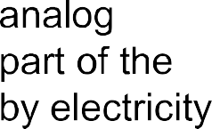’s “ ”


it






its

s

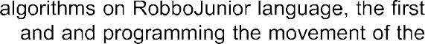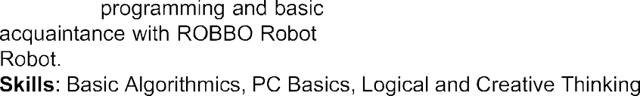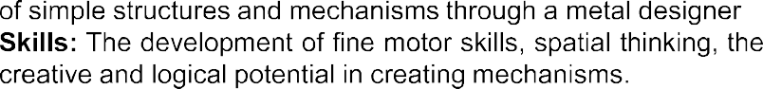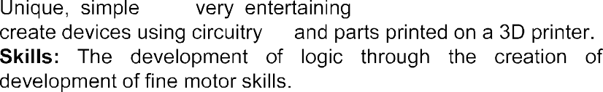the

kit
kit

kit Why

s
kit



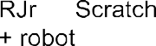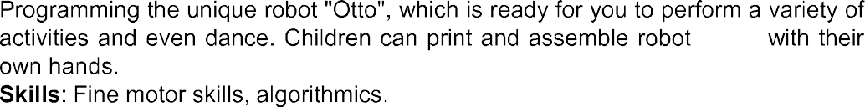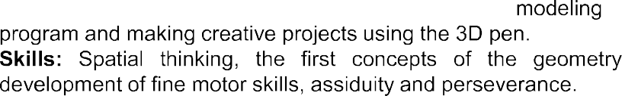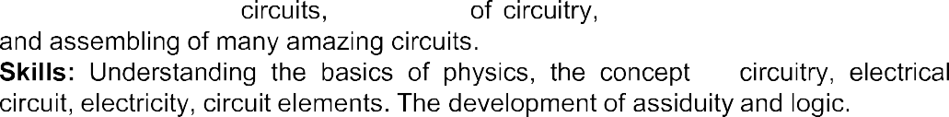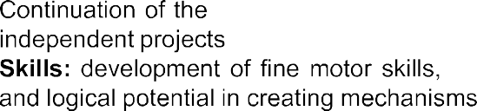the

kit kit

“Otto”

year’s

“Expert“ Work

“construction”



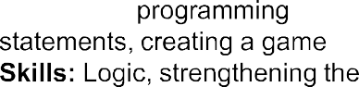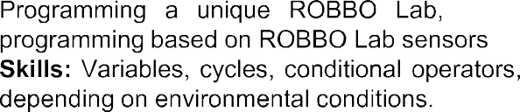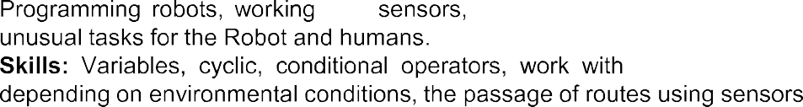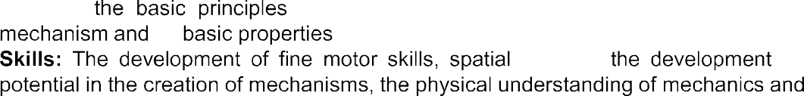the

Smart

from
"crocodile”

kit
from

“Expert“ its “Expert"

its

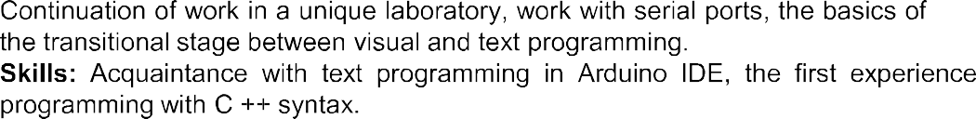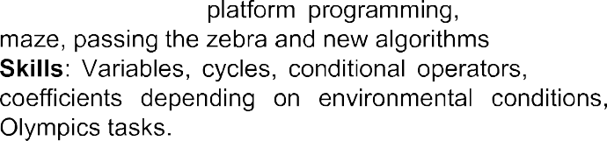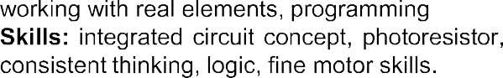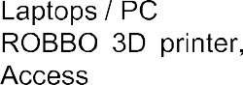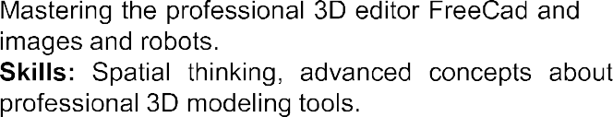the

"crocodile”

from

“Expert“

kit

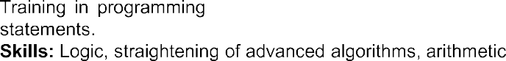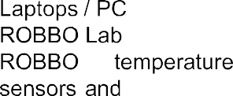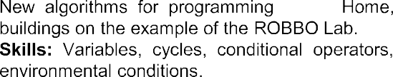the

Smart Smart Smart “smart”

"crocodile”
from

kit

kit

tracks

kit

kit
Work kit

15 years. Conscious robotics. Second year

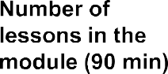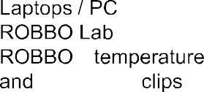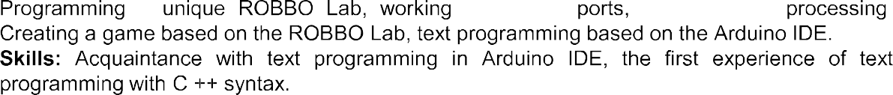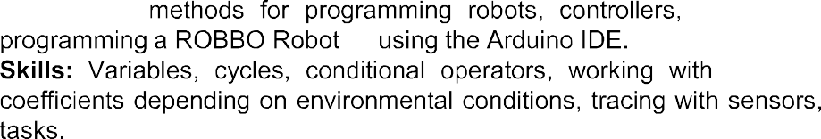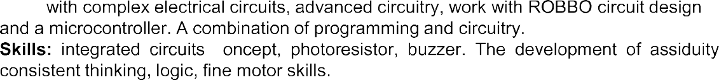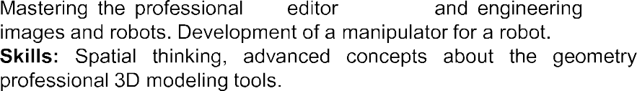"crocodile”

kit

kit

kit
tracks from

kit Work kit

c

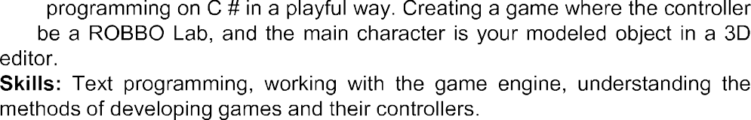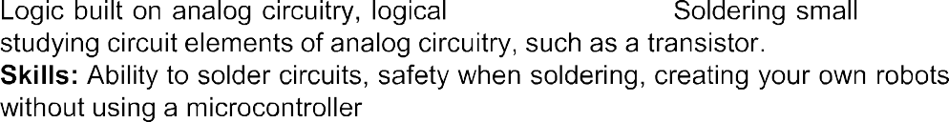the

MeArm,

Work









●
● 
●








from

●
●
●
●
●
●

“body” 

